**Elective 3**

**Final Project Documentation**

**Submitted by:**

Eziera Yvanne Gabriel

BSCpE V-2

**Submitted to:**

**Danilo Madrigalejos Jr.**

Instructor

2016

**Introduction**

Pig Latin is a language game in which words in English are altered. The objective is to conceal the meaning of the words from others not familiar with the rules. The reference to Latin is a deliberate misnomer, as it is simply a form of jargon, used only for its English connotations as a strange and foreign-sounding language.

Pig Latin is not actually a language but a language game that children (and some adults) use to speak “in code.” Pig Latin words are formed by altering words in English.

*Here’s how it works:*

First, pick any English word. We’ll use “dictionary.”

Next, move the first consonant or consonant cluster to the end of the word: “ictionary-d.”

Now, add “ay” to the end of the word: “ictionary-day.”

That’s all there is to it; you’ve formed a word in Pig Latin.

**Scope and Delimitations**

These are the scope of the project:

* The application encrypts the words in Pig Latin’s rule.
* The application contains a menu strip where the rules are listed.
* The application has a playful music background.
* The Pig Latin accepts one word at a time.
* The application accepts the Enter key as “Translate It!” button and Esc key as “Clear” button.

These are the delimitations of the project:

* The Pig Latin application does not accept spaces in the textbox.
* The application only accepts letters. The textbox will not accept numeric and special characters.
* The player cannot go back to the home page once the player went to the main page.

**Screen capture**

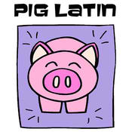

Figure 1 Pig Latin icon used in the application

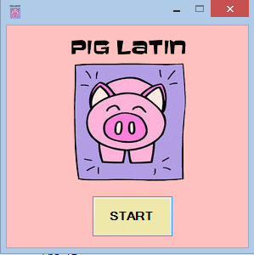

Figure 2 Pig Latin home page

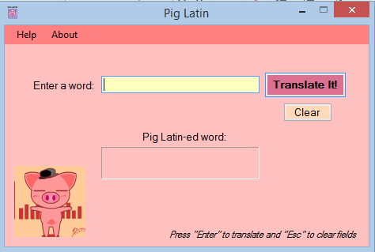

Figure 3 Pig Latin Main page

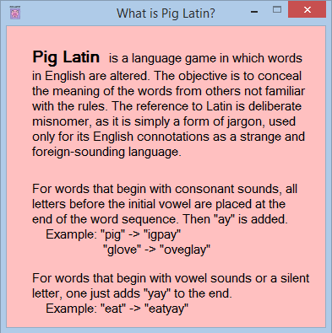

Figure 4 Help page

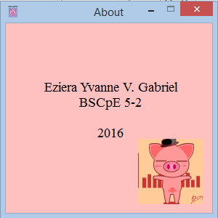

Figure 5 About page

**Source codes**

MainForm.vb

' EZIERA YVANNE V. GABRIEL

' BSCpE 5-2

' 2016

Public Class MainForm

Dim pigLatinWord As String ' String where the input and output word will be stored

Dim vowels() As Char ' Char array where vowels are stored

Dim prefixLength As Integer ' Integer where number of consonants in the beginning of the word will be stored

Dim suffixString As String ' String where suffixes "yay" and "ay" are stored. Value will depend on the value of prefixLength

Private Sub mainForm_Load(sender As Object, e As EventArgs) Handles MyBase.Load

button_Main.BackColor = Color.PaleVioletRed ' changes button_Main's color to PaleVioletRed after mainForm loads

button_Clear.BackColor = Color.PeachPuff ' changes button_Clear's color to PeachPuff after mainForm loads

PlayBackground() ' at line 66, plays theme.wav audio after MainForm loads

End Sub

Public Sub button_Main_Click(sender As Object, e As EventArgs) Handles button_Main.Click

If textbox_Word.Text = "" Then ' if textbox is empty

textbox_Word.Text = "" ' it will remain empty as well as label_PigLatinWord

textbox_Word.Focus() ' focus is still on textbox for faster input of next word

PlayErrorSound() ' at Line 71, will play your system's error sound

Else ' else, if textbox is not empty (which means you input a word)

pigLatinWord = textbox_Word.Text ' contents of the textbox will be stored in String variable pigLatinWord

vowels = "AEIOU0".ToCharArray() ' a string of vowels and numbers is converted to Char array and stored to "vowels" Array

prefixLength = pigLatinWord.ToUpper().IndexOfAny(vowels) ' ToUpper() = pigLatinWord will be converted to uppercase letters

' ... ' IndexOfAny() = reports the zero-based index of the first occurence of character that belongs in the "vowels" array.

' ... ' store the index to prefixLength variable

' For example a word "latin" was entered.

' Public function IndexOfAny() (with "vowels" array as its parameter), will return the index of the first "vowels" character it detected in the string "latin".

' In this case, 'a' is the first "vowels" character to appear and 'a' has the index of 1 (zero-based). Therefore, the prefixLength variable will have a value of 1.

' Somehow in this program, IndexOfAny function counts the number of consonants there are in the beginning of pigLatinWord to detect if the word begins with a vowel or with a consonant.

' If the word is "eat", IndexOfAny() will return a value of 0 because a "vowels" character, e, appeared in the beginning of the word, therefore there are 0 consonants in the beginning of the word.

If (prefixLength = 0) Then ' if prefixLength is 0, it means that the word begins with a vowel

suffixString = "yay" ' accourding to the rules of Pig Latin, if the word starts with a vowel, the suffix will be "yay"

Else ' else, if prefixLength has a value other than 0, (starts with a consonant)

suffixString = "ay" ' the suffix will be "ay"

End If

pigLatinWord = pigLatinWord.Substring(prefixLength).ToLower() & pigLatinWord.Substring(0, prefixLength).ToLower() & suffixString

' First Substring() = pigLatinWord will be displayed starting from the Substring parameter prefixLength. If prefixLength has a value, pigLatinWord will be cut and the second half will be taken.

' Second Substring() = after displaying the second half of the word, the first half will be displayed after it. Remember, Pig Latin is an encryption game used to hide the original words.

' ... It jumbles the letters of the words in a consistent manner.

' suffixString will be added in the end after the words are jumbled

' the jumbled word will be stored to pigLatinWord variable and will be its new value

label_PigLatinWord.Text = pigLatinWord ' the new pigLatinWord will be displayed in the label as the encrypted word

End If

End Sub

Private Sub button_Clear_Click(sender As Object, e As EventArgs) Handles button_Clear.Click

textbox_Word.Text = "" ' clears fields

label_PigLatinWord.Text = "" ' when button is clicked

End Sub

Private Sub HowToPlayToolStripMenuItem_Click(sender As Object, e As EventArgs) Handles WhatIsPigLatinStripMenuItem.Click

Dim WhatIsPigLatin As New WhatIsPigLatin ' show WhatIsPigLatin form

WhatIsPigLatin.Show() ' when What Is Pig Latin menu is clicked

End Sub

Private Sub AboutToolStripMenuItem_Click(sender As Object, e As EventArgs) Handles AboutToolStripMenuItem.Click

Dim About As New About ' show About form

About.Show() ' when About menu is clicked

End Sub

Private Sub textbox_Word_KeyDown(sender As Object, e As KeyEventArgs) Handles textbox_Word.KeyDown

If e.KeyCode = Keys.Space Then ' space is not allowed

e.SuppressKeyPress = True ' to be typed in the textbox

End If

End Sub

Private Sub textbox_Word_KeyPress(sender As Object, e As KeyPressEventArgs) Handles textbox_Word.KeyPress

If Not (Asc(e.KeyChar) = 8) Then

Dim allowedChars As String = "abcdefghijklmnopqrstuvwxyz" ' accepts only letters, and;

If Not allowedChars.Contains(e.KeyChar.ToString.ToLower) Then ' rejects numbers and special characters

e.KeyChar = ChrW(0)

e.Handled = True

End If

End If

End Sub

Sub PlayBackground() ' plays the theme.wav resource as the form's background music

My.Computer.Audio.Play(My.Resources.theme, _

AudioPlayMode.Background)

End Sub

Sub PlayErrorSound() ' plays the system's Asterisk sound as an error sound

My.Computer.Audio.PlaySystemSound( _

System.Media.SystemSounds.Asterisk)

End Sub

End Class

TitleScreen.vb

' EZIERA YVANNE V. GABRIEL

' BSCpE 5-2

' 2016

Public Class TitleScreen

Private Sub button_Start_Click(sender As Object, e As EventArgs) Handles button_Start.Click

Dim MainForm As New MainForm ' opens the MainForm form

MainForm.Show() ' and closes the TitleScreen form

Me.Close() ' when button_Start is clicked

End Sub

Private Sub TitleScreen_KeyDown(sender As Object, e As KeyEventArgs) Handles Me.KeyDown

If e.KeyCode = Keys.Escape Then Me.Close() ' closes the TitleScreen form when "Esc" is pressed

End Sub

Private Sub TitleScreen_Load(sender As Object, e As EventArgs) Handles MyBase.Load

button_Start.BackColor = Color.PaleGoldenrod ' turns button_Start to PaleGoldenrod color

PlayBackground() ' at Line 18, plays theme.wav audio after TitleScreen loads

End Sub

Sub PlayBackground() ' plays the theme.wav resource as the form's background music

My.Computer.Audio.Play(My.Resources.theme, _

AudioPlayMode.Background)

End Sub

End Class

HowToPlay.vb

' EZIERA YVANNE V. GABRIEL

' BSCpE 5-2

' 2016

Public Class WhatIsPigLatin

Private Sub WhatIsPigLatin_KeyDown(sender As Object, e As KeyEventArgs) Handles Me.KeyDown

If e.KeyCode = Keys.Escape Then ' form will close

Me.Close() ' when "Esc" is pressed

End If

End Sub

End Class

About.vb

' EZIERA YVANNE V. GABRIEL

' BSCpE 5-2

' 2016

Public Class About

Private Sub About_KeyDown(sender As Object, e As KeyEventArgs) Handles Me.KeyDown

If e.KeyCode = Keys.Escape Then ' form will close

Me.Close() ' when "Esc" key is pressed

End If

End Sub

End Class